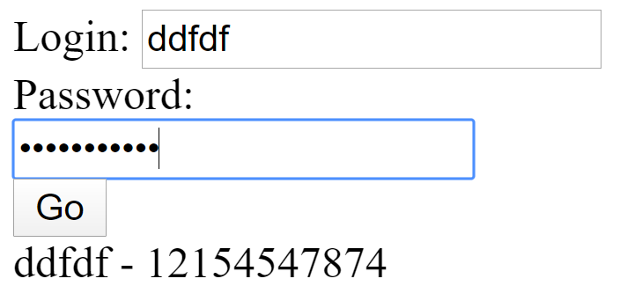
<!DOCTYPE html>
<html lang="en">
<head>
<meta charset="UTF-8" />
<meta name="viewport" content="width=device-width, initial-scale=1.0" />
<meta http-equiv="X-UA-Compatible" content="ie=edge" />
<title>Document</title>
<script src="https://cdn.jsdelivr.net/npm/vue/dist/vue.js"></script>
</head>
<body>
<div id="app">
Login:
<input type="text" v-model="login" placeholder="Type login here" /><br />
Password: <input type="password" v-model="pass" /><br />
<button @click="onGo" :disabled="isButtonDisabled">Go</button>
<div>{{res}}</div>
</div>
<script>
var app = new Vue({
el: "#app",
data: {
login: null,
pass: "",
res: ""
},
computed: {
isButtonDisabled() {
return !(this.login && this.pass.length > 8);
}
},
methods: {
onGo() {
alert("Go");
this.res = this.login + " - " + this.pass;
}
}
});
</script>
</body>
</html>

Приклад 2.
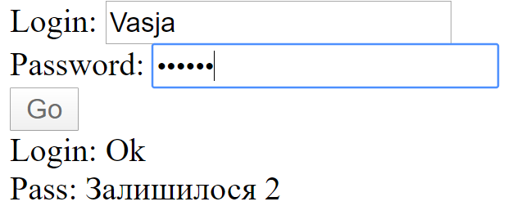

<!DOCTYPE html>
<html lang="en">
<head>
<meta charset="UTF-8" />
<meta name="viewport" content="width=device-width, initial-scale=1.0" />
<meta http-equiv="X-UA-Compatible" content="ie=edge" />
<title>Document</title>
<script src="https://cdn.jsdelivr.net/npm/vue/dist/vue.js"></script>
</head>
<body>
<div id="app">
Login:
<input type="text" v-model="login" placeholder="Type login here" /><br />
Password: <input type="password" v-model="pass" /><br />
<button @click="onGo" :disabled="isButtonDisabled">Go</button>
<div>Name: {{msg1}}</div>
<div>Pass: {{msg2}}</div>
</div>
<script>
var app = new Vue({
el: "#app",
data: {
login: null,
pass: "",
msg1: "",
msg2: ""
},
watch: {
pass(newVal,oldVal) {
this.msg1 = this.login ? "Ok" : "Pleaser enter login";
this.msg2 =
this.pass.length >= 8
? "Ok"
: `Залишилося ${8 - this.pass.length}`;
},
isButtonDisabled(newVal) {
if (newVal === false) {
this.msg1 = "";
this.msg2 = "";
}
}
},
computed: {
isButtonDisabled() {
return !(this.login && this.pass.length >= 8);
}
},
methods: {
onGo() {
alert("Go");
this.res = this.login + " - " + this.pass;
}
}
});
</script>
</body>
</html>

